create database emp;
use emp;

CREATE TABLE employee (
empno VARCHAR(5) PRIMARY KEY,
emp_name VARCHAR(50),
dept VARCHAR(50),
salary DECIMAL(10, 2),
doj DATE,
branch VARCHAR(50)
);

INSERT INTO employee VALUES
('E101','Amit','Production',45000.00,'2000-03-12','Bangalore'),
('E102','Amit','HR',70000.00,'2002-07-03','Bangalore'),
('E103','Sunita','Management',120000.00,'2001-01-11','Mysore'),
('E104','Sunita','IT',67000.00,'2001-08-01','Mysore'),
('E105','Mahesh','Civil',145000.00,'2003-09-20','Mumbai'),
('E106','Ravi','Production',55000.00,'2004-02-15','Bangalore'),
('E107','Priya','HR',75000.00,'2002-06-12','Mysore'),
('E108','Kiran','IT',68000.00,'2003-03-22','Bangalore'),
('E109','Neha','Management',125000.00,'2001-05-05','Mumbai'),
('E110','Mahesh','Civil',155000.00,'2004-10-10','Bangalore');

Select * From Employee;
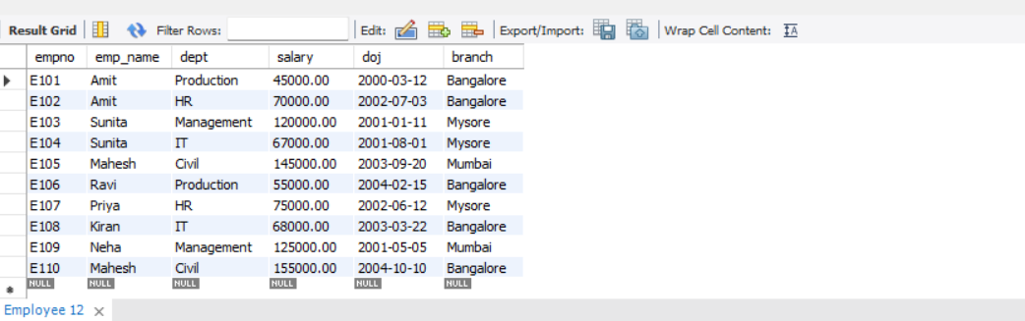
Retrieve EMPNO and SALARY of all employees
SELECT empno, salary FROM employee;
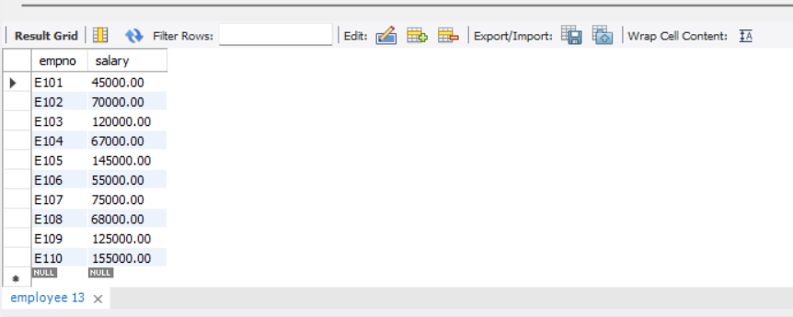
SELECT COUNT(*) AS total_employees FROM employee;

SELECT SUM(salary) AS total_salary FROM employee
SELECT AVG(salary) AS avg_salary FROM employee;

SELECT MAX(salary) AS max_salary FROM employee;

SELECT MIN(salary) AS min_salary FROM employee;

SELECT emp_name, SUM(salary) AS total_salary
FROM employee
GROUP BY emp_name;
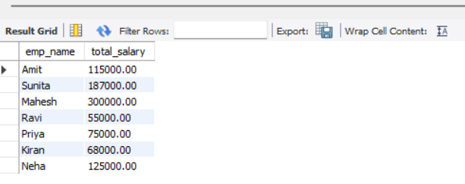
SELECT emp_name, AVG(salary) AS avg_salary
FROM employee
GROUP BY emp_name;

SELECT emp_name, MAX(salary) AS max_salary
FROM employee
GROUP BY emp_name;

SELECT emp_name, MIN(salary) AS min_salary
FROM employee
GROUP BY emp_name;
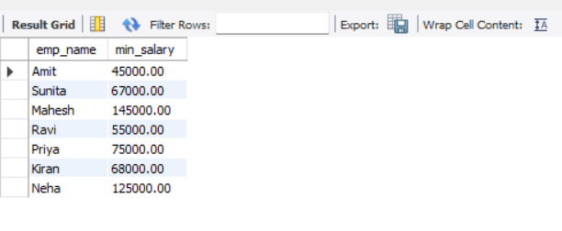
SELECT emp_name, AVG(salary) AS avg_salary
FROM employee
GROUP BY emp_name
HAVING AVG(salary) > 60000;

SELECT dept, SUM(salary) AS total_salary
FROM employee
GROUP BY dept
HAVING SUM(salary) > 150000;

SELECT branch, AVG(salary) AS avg_salary
FROM employee
GROUP BY branch
HAVING AVG(salary) > 70000;


